Kīpuni Aloha no Maui
Embrace beloved Maui

Communications Toolkit

Please join us as we come together for Maui and help us spread the word on social media and online about Kīpuni Aloha no Maui, a statewide day-long vigil for beloved Maui on Sept. 1, 2023.

Here are ways you can participate:
- Hold your own in-place vigil and share it through your respective network and online/social channels, using the resources below.
- Please complete the form to tell us about your in-place vigil (any public vigils will be listed on our website and through social channels): https://www.surveymonkey.com/r/ZGZ35M9
- Stream the sunrise, noon, and sunset ceremonies, live or recorded, during your vigil. https://www.youtube.com/olelocm

Social Media and Website

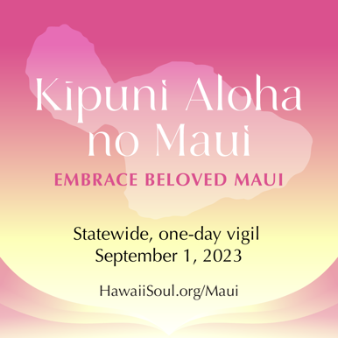

Link to downloadable graphic for posting on social channels and website

Suggested Caption for Social Media Posts:

We are joining hands across Hawai‘i on Sept. 1 for ​​Kīpuni Aloha no Maui, a statewide day-long vigil for beloved Maui. To unify the islands in support for Maui, the vigil will center on emotional and spiritual healing that is rooted in traditional Native Hawaiian practices and include leaders from diverse faiths. The live stream is in partnership with ‘Olelo, Akakῡ Community Media, KAKU 88.5 FM, Maui Stream, Hawaiʻi News Now, KITV4, KHON2, Nā Leo TV, Hō‘ike TV, and other media partners and on YouTube.

Tune in on September 1 at sunrise, noon and sunset or host your own vigil by livestreaming the ceremonies. Visit HawaiiSoul.org/Maui for more information and the broadcast schedule.

#MauiStrong #MauiVigil and #KipuniAlohaNoMaui

# # #

Sample In-Person Vigil Gathering Invitation Email:

Aloha,

The pain that the people of Maui are enduring is unimaginable. An urgent need for prayer, cleansing, and reflection is needed so that together, we can create a space for grief, healing, and the opportunity to come together as one.

We hope you will join us as one ‘ohana in support of Maui on Sept. 1 for ​​Kīpuni Aloha no Maui, a statewide day-long vigil for beloved Maui. The vigil will center on emotional and spiritual healing that is rooted in traditional Native Hawaiian practices and include leaders from diverse faiths.

We will be streaming the live [sunrise/noon/sunset] ceremony from [time] at [location]. [add in further detail about your vigil for employees, members, and/or community.]

# # #

